Section 1 - Multiple Choice questions (1 mark each)

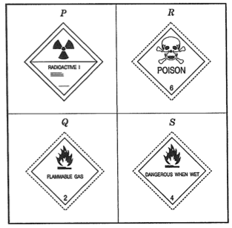
1. Labels are placed on chemicals to show how they are dangerous. Some of these labels, P, Q, R and S, are shown below:

Below are descriptions for some chemicals:

- Hydrogen gas explodes when it is ignited in air.
- Hydrocyanic acid is one of the most toxic chemicals known.
- Calcium carbide reacts with water giving off ethane gas. Ethyne is explosive.
- Cobalt-12 gives off radioactive rays.

Which one below has the chemicals matched up with the labels P to S ?

 | Hydrogen | Hydrocyanic acid | Calcium carbide | Cobalt-60
a | S | R | Q | P
b | S | R | P | Q
c | Q | S | R | P
d | Q | R | S | P

2. A metal is called amphoteric if it reacts with an acid and with a base. Information about some metals,P to U, is given below:
Metal | Reaction with acid | Reaction with base
P | gas given off | no reaction
Q | no reaction | no reaction
R | gas given off | gas given off
S | gas given off | no reaction
T | gas given off | gas given off
U | no reaction | no reaction

Which metals are amphoteric?

a. T and U
b. Q and U
c. P and S
d. R and T

3. Look at the table of information below:
Chemical | Reaction with zinc | Reaction with olive oil | Reaction with litmus
strong acid | bubbles evolved rapidly | no reaction | turns red
strong base | no reaction | soap forms quickly | turns blue
weak acid | bubbles evolved slowly | no reaction | turns red
weak base | no reaction | soap forms quickly | turns blue

Some mineral water is tested. It does not react with olive oil, it turns litmus red and it gives off bubbles slowly when added to zinc. The mineral water is most likely to be -

a. a strong acid.
b. a strong base.
c. a weak acid.
d. a weak base.

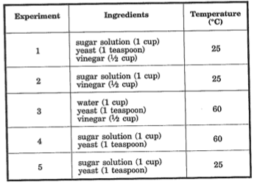
4. Four things can affect the way alcohol is made. These are the amount of sugar, the presence of yeast, the presence of vinegar, and the temperature. Five mixtures are made to see the effects of these on making alcohol.

Which two mixtures would you use to test the effects of vinegar only ?

a. 1 and 4
b. 1 and 2
c. 3 and 4
d. 1 and 5

5. Air is a mixture of oxygen and nitrogen. The amount of nitrogen in air is measured:
Air sample
Total volume | 100 mL
Volume of nitrogen | 80 mL

Which one below is correct ?

a. The volume of nitrogen in air is the same as the volume of oxygen.
b. The volume of oxygen in air is four times the volume of nitrogen.
c. The volume of oxygen in air is half the volume of nitrogen.
d. The volume of nitrogen in air is four times the volume of oxygen.

6. Metals look shiny, conduct electricity and they bend when hit with a hammer. Non-metals are the ‘opposite’ of metals.

Look at the information for some chemicals, P to T:
Chemical | Appearance | Conducts electricity? | Result when hit with a hammer
P | dull | no | shatters
Q | shiny | yes | bends
R | dull | no | shatters
S | shiny | yes | bends
T | shiny | yes | bends

From this table we can say that -

a. P and T are metals.
b. P and R are non-metals.
c. Q and S are non-metals.
d. S and P are metals.

Section 2 - Short Answer Section - write your answers in the spaces provided.

1. How well a metal conducts electricity is given the symbol K. The bigger the K number is, the better the metal conducts electricity. Look at the table below:

a. Which metal is the third best at conducting electricity? (1 mark)

_______________________________

b. Copper is a better conductor than gold. However, copper is not as good as silver.
What range would copper’s K number be in? (1 mark)
Metal | K number
cobalt | 15
gold | 45
lead | 5
silver | 60
iron | 10

________________________________________________________

c. If lead is the standard, its K number is changed to ‘one’. The new K number of cobalt would be 3, while for gold it would be 9. What would the new K numbers for silver and iron be? (2 marks)

silver _________ gold _________

2. Read the following newspaper article. It appeared in the Brisbane Courier Mail on
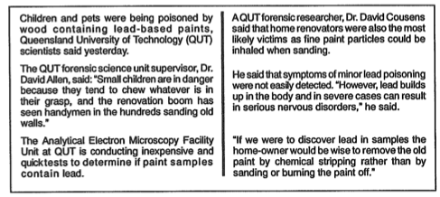
April 18, 1990.

Use this article to answer the questions below:

a. Which two groups of people are at risk from lead poisoning? (1 mark)

____________________________________________________________

b. What are you advised to do if you are renovating an old house? (2 marks)

___________________________________________________________________

___________________________________________________________________

___________________________________________________________________

___________________________________________________________________

c. Give one reason why lead is a dangerous chemical. (1 mark)

___________________________________________________________________

___________________________________________________________________

___________________________________________________________________

___________________________________________________________________

d. During the term that you were studying Chemistry you did an extensive study of one room in your house where chemicals were being stored and/or used. Describe one of the more ‘dangerous’ chemicals by listing

a) the name of the chemical, ________________________________________

b) why it is dangerous, _______________________________________________

___________________________________________________________________

___________________________________________________________________

and c) how you go about making sure that it doesn't cause harm to other people, pets and the environment.

___________________________________________________________________

___________________________________________________________________

___________________________________________________________________

___________________________________________________________________

___________________________________________________________________

___________________________________________________________________

___________________________________________________________________

___________________________________________________________________

___________________________________________________________________

___________________________________________________________________
(total: 6 marks)

e) i) There are chemicals that we use constantly in our homes or in some of your work places. Name five products that you have studied and used and give an idea of how these are used. (10 marks)

___________________________________________________________________

___________________________________________________________________

___________________________________________________________________

___________________________________________________________________

___________________________________________________________________

___________________________________________________________________

___________________________________________________________________

___________________________________________________________________

___________________________________________________________________

___________________________________________________________________

___________________________________________________________________

___________________________________________________________________

___________________________________________________________________

___________________________________________________________________

___________________________________________________________________

ii) Why are people still like to use some of these chemicals knowing full well that they may be harmful? Where do they go to find out more about the dangers of some of these chemicals? (4 marks)

___________________________________________________________________

___________________________________________________________________

___________________________________________________________________

___________________________________________________________________

___________________________________________________________________

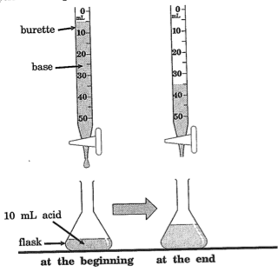
3. A burette is used to accurately add one solution to another. The drawing below shows an experiment using a burette.

a. How many mL (millilitres) of base was added to the flask from the burette?(1 mark)

____________________________

b. Which one below would you use to measure the acid accurately before putting it in the flask? Circle or shade in the correct answer. (1 mark)
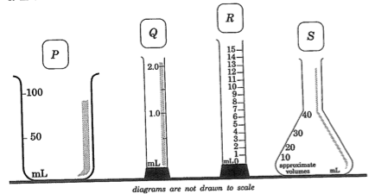

c. A burette should not be rinsed with water before using it. Suggest a reason why.
(2 marks)
___________________________________________________________________

___________________________________________________________________

___________________________________________________________________

___________________________________________________________________

4. The instructions for testing pool-water and the chemicals used are given below (the instructions came from the United States of America and therefore use inches (1 in = 2.5cm):

a. Tom decided to test his pool-water for chlorine. He rinsed the Cl vial with pool- water. He took some water about 18 inches from below the surface of the water near the edge. He added 5 drops of solution ‘A’ that he bought a couple of years ago. He placed the lid on the vial and shook it a few times. After about 10 minutes, he matched up the colours. He got a reading of 1.9.

Tom made four mistakes in his method. What are they?? (4 marks)

___________________________________________________________________

___________________________________________________________________

___________________________________________________________________

___________________________________________________________________

___________________________________________________________________

___________________________________________________________________

___________________________________________________________________

___________________________________________________________________

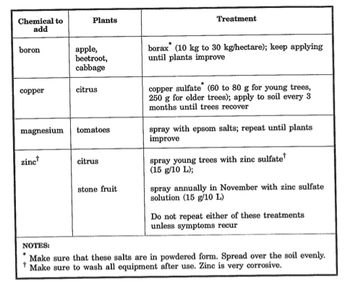
___________________________________________________________________

___________________________________________________________________

b. State one thing you should do when using the solutions safely. (2 marks)

___________________________________________________________________

___________________________________________________________________

___________________________________________________________________

___________________________________________________________________

___________________________________________________________________

5. Adding certain chemicals to unhealthy plants helps them to grow better. Look at the information below:

a. What’s the maximum amount of borax you would add to 20 hectares of apples?
(1 mark)

______________________________

b. Describe briefly how you would test whether using epsom salts makes tomatoes grow better. (4 marks)

___________________________________________________________________

___________________________________________________________________

___________________________________________________________________

___________________________________________________________________

___________________________________________________________________

___________________________________________________________________

___________________________________________________________________

___________________________________________________________________

___________________________________________________________________

___________________________________________________________________

c. What does the information say you should do when adding all of these salts?
(2 marks)

___________________________________________________________________

___________________________________________________________________

___________________________________________________________________

___________________________________________________________________

___________________________________________________________________

6. You are asked by your manager at work to trial three different detergents (A, B and C) to see which one will wash and clean the pots, pans and trays you use the quickest and most effectively. Write up an experiment where you scientifically prove the effectiveness of each of the detergents. You MUST write it up as a scientific report so that he/she can be certain of your decision. Remember that someone else must be able to follow your report and do it themselves using your method and achieve the same results that you did. Write it out using the following headings.

AIM:

Variables (independent, dependent and controlled)

HYPOTHESIS

MATERIALS REQUIRED

METHOD USED

RESULTS - make some up into a table and graph these

CONCLUSION - from your made up results making sure you say exactly why the detergent makes a good choice.

If you think we need more time then you could add the Teflon Comprehension section from your 2012 paper.

